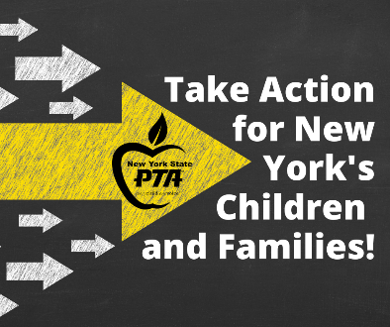
We need YOUR voice!

2.4 million children are enrolled in New York State public schools. Thanks to NYS PTA Advocacy Efforts, 2.4 million children have:
- a seat on their morning bus ride to school
- attended kindergarten
- access to healthy school meals
- parents & guardians with access to meaningful engagement in their children’s schools

Imagine how much more we could do for NYS’ children if you added your voice to our chorus of nearly 225,000 members? Fight for their future–become a member of NYS PTA today.

DELETE THIS BOX
Personalize this form for your unit. All of the areas in RED can be adjusted to the needs of your unit. Change the RED to BLACK once edited.
MEMBER INFORMATION (Please print clearly)
❑ Enclosed is our 2024-2025 Total Membership Dues - $__________
(Make checks payable to the add your unit name here or send exact cash)
Note: All returned checks will be assessed a fee.
MEMBER NAME | Standard $PRICE  Student $PRICE | Additional Family Member $PRICE  Teacher/Staff $PRICE
EMAIL - for eCard (leave blank for student) | MOBILE – optional (leave blank for student)

MEMBER NAME | Standard $PRICE  Student $PRICE | Additional Family Member $PRICE  Teacher/Staff $PRICE
EMAIL - for eCard (leave blank for student) | MOBILE – optional (leave blank for student)

MEMBER NAME | Standard $PRICE  Student $PRICE | Additional Family Member $PRICE  Teacher/Staff $PRICE
EMAIL - for eCard (leave blank for student) | MOBILE – optional (leave blank for student)

MEMBER NAME | Standard $PRICE  Student $PRICE | Additional Family Member $PRICE  Teacher/Staff $PRICE
EMAIL - for eCard (leave blank for student) | MOBILE – optional (leave blank for student)
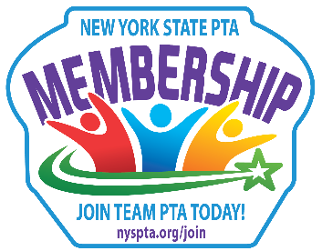
SKIP the FORM and JOIN ONLINE!
Units - add your Online Store LINK here or create a QR Code using a free online QR Code creator
For PTA Use Only:
Amount $__________ Cash Check
Check #___________ Ck Date ________
Date Received ______________________
Receipt # ___________________________
You can edit and use this as the backside of your form or delete entirely

Fill in PTA NAME HERE needs YOUR support! How can you help?
Join – Donate – Volunteer

VOLUNTEER

❑ Please add me to the Master Volunteer list
We will email you throughout the year with information and volunteer opportunities as they arise. The goal is to keep you informed on current school events and opportunities. By signing up, there is no obligation to help and you can be removed from the list at any time.

WHY PTA?

NYS PTA was founded by passionate individuals like you who wanted to ensure the best possible world for all children. From working for child labor laws and seats on school buses, to school meals, pre-k programs, Special Education supports and more, NYS PTA members unite to put our advocacy into action. Help us honor the legacy of our Founders’ and become a member of our unit today!

Some examples are:

EVENTS/PROGRAMS (Customize by listing what your PTA provides to the school or delete section)

FUNDRAISING /DONATIONS (Customize by listing Fundraisers or ways the member can donate or delete section)

MEMBERSHIP FORMS ARE DUE BY fill in date, 2025
Questions? Contact fill in contact information
THANK YOU for joining!
Your membership and support
will ensure that this will be a fabulous year!

