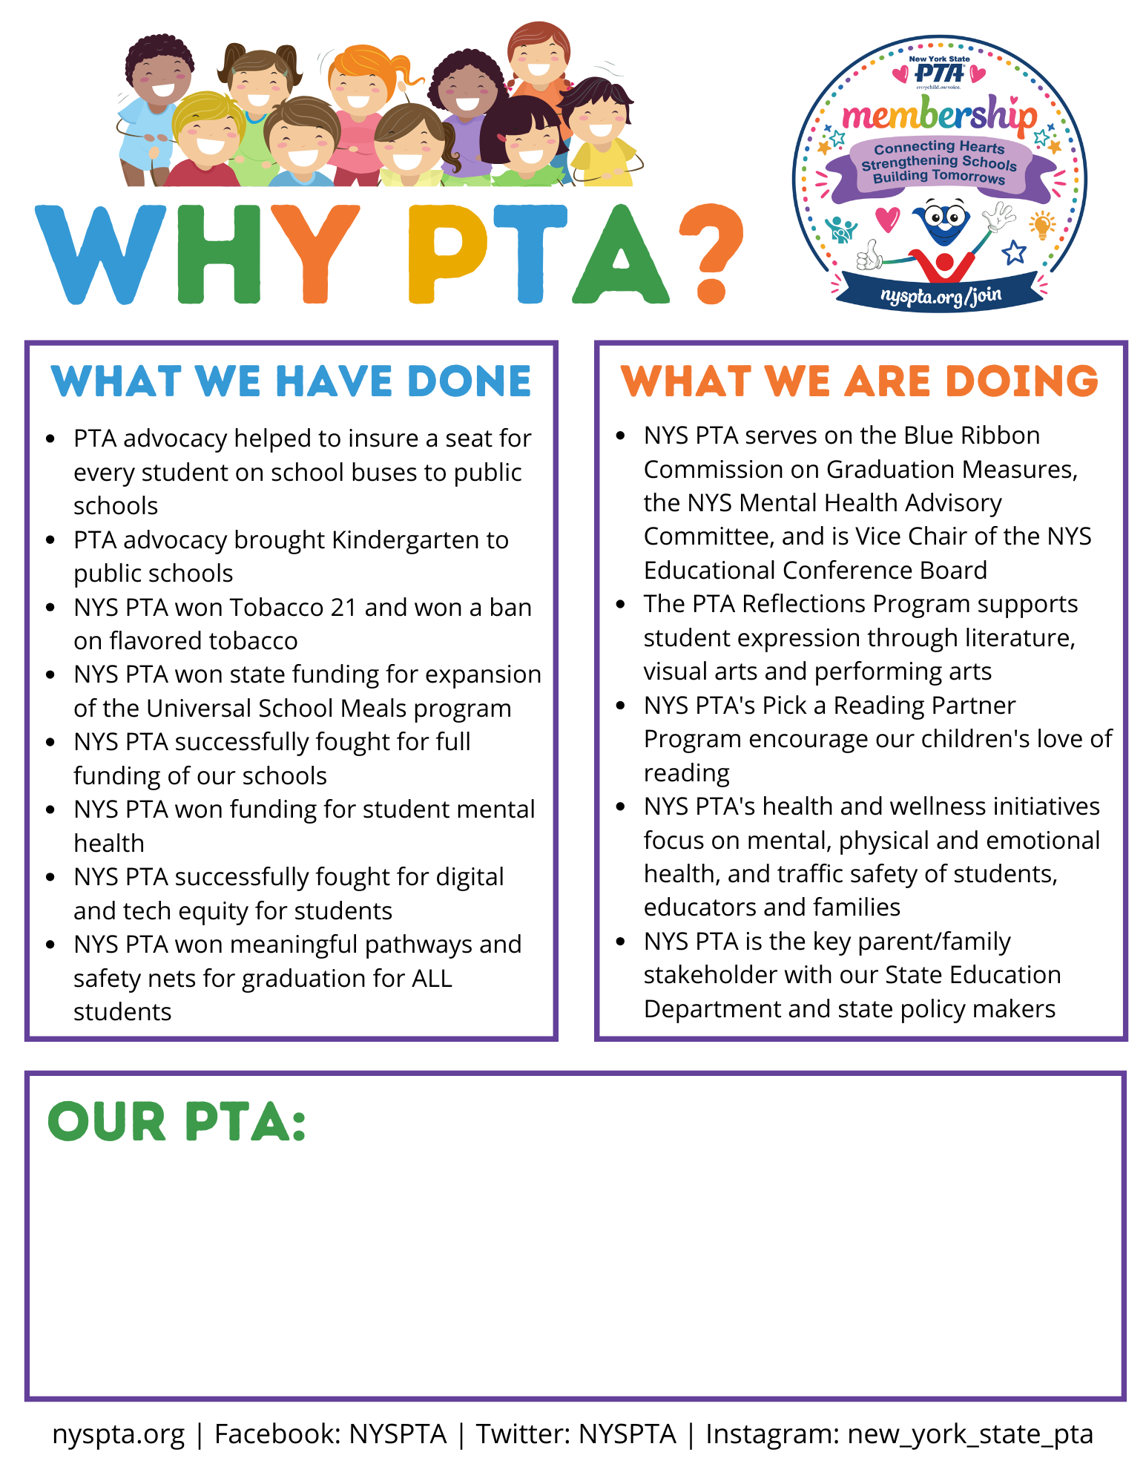
[Replace this text with your PTA’s accomplishments.]

